Vendor Event Information
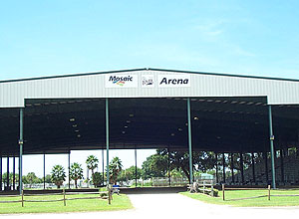

Event Location:
Manatee County Fairgrounds, Mosaic Arena
Event Date: Saturday, June 27, 2026
Event Time: 9:00 – 4:00

Important Notes:
- This is an outdoor event held under the arena rooftop.
- Vendors are responsible for bringing their own display materials, including tents, tables, and chairs.
- No water or electricity will be available at the venue.

Display Information:
- 10 x 10 Space on Dirt Floor

- Given a Specific Spot Number:

Thank You for Participating!
We look forward to a successful event together! If you have any questions, please contact Donna Kutinsky 941-685-7323 or donna@moreofhim.org

